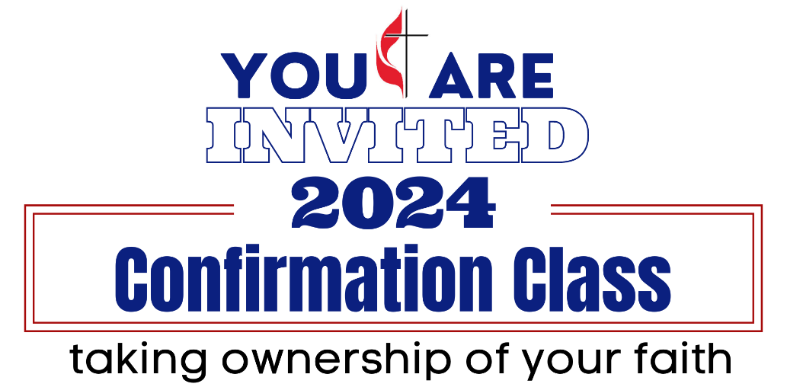

CLASSES:
March 24
April 7, 14, 28
May 5
10:40 AM – 12:00 PM
Will begin immediately after our weekly youth time in chapel

CONFIRMATION WEEKEND
Friday, May 10th:
6:30 PM – 7:00 PM Parent Meeting
7:00 PM – 9:00 PM I Am the Church
Sunday, May 12th:
Confirmation Sunday @ 9:30 AM

Confirmation is open to all youth ages 6th – 12th grade.
Participants are highly encouraged to attend all the activities listed above.

